1. What Design Pattern is related to the following keywords?

*Eager Initialization, Lazy Initialization, Bill Pugh’s Solution, Double-Checked Locking, Static block Initialization, Enum Solution*

* Decorator
* **Singleton**
* Abstract Factory
* Visitor

1. Select the most problematic Design Pattern in the following preconditions

*What design pattern is difficult to be adopted if various clients do not agree on the default behaviour of the object?*

* **NullObject**
* Composite
* Strategy
* Template Method

1. Identify what DP is using an application designed to simulate and study robots interactions

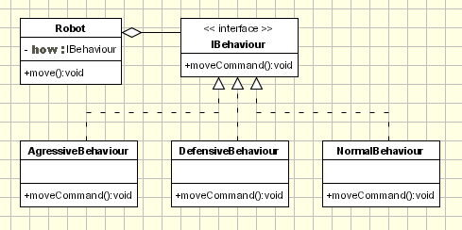

* Abstract Factory
* Command
* Template Method
* **Strategy**

1. What is true for the following Chain of Responsibility pattern UML class diagram?

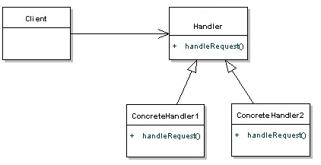

* It is valid UML class diagram
* *handleRequest* method should take next handler as parameter
* **There is missing reference to a next handler**
* Handler should be renamed to Element

1. NullObject is a ____________ design pattern?

1) creational

2) structural

3**) behavioral**

4) concurrency

1. What change is needed in the class diagram to represent NullObject design pattern?

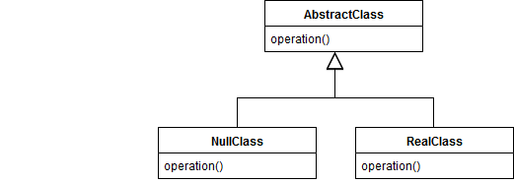

* Nothing
* Missing public isNull() in Abstract/Null/RealClass
* **Almost correct (missing Client)**
* NullClass should inherit from RealClass (not AbstractClass)